
THINK VEG BOX • THINK AUSTEN’S PREMIUM
D3 SPECTRUM BUSINESS CENTRE
ANTHONY’S WAY
ROCHESTER ME2 4NP
T: 01634 816100
E: contact@austensgroup.com
W: www.austensgroup.com


VEG BOX CONTENTS & RECIPES FOR WEEK COMMENCING 12TH JANUARY 2026

E A T L O C A L ⋅ L I V E B E T T E R

VEG BOX CONTENTS

BOX SIZE &  CONTENTS | SMALL  BOX | MEDIUM  BOX | LARGE  BOX | WHERE IT IS GROWN | STORAGE INSTRUCTIONS
LOCAL COX APPLES | √ | √ | √ | COXHEATH | ROOM TEMPERATURE
LOCAL CONFERENCE PEARS | √ | √ | √ | COXHEATH | ROOM TEMPERATURE
LEAFY CLEMENTINES | √ | √ | √ | SPAIN | ROOM TEMPERATURE
LOCAL DESIREE RED POTATOES | √ | √ | √ | BIRCHINGTON | COOL, DRY PLACE
LOCAL BABY SPINACH | √ | √ | √ | WEST MALLING | REFRIGERATE
COURGETTES | √ | √ | √ | SPAIN | REFRIGERATE
LOCAL SPROUT TOPS | √ | √ | √ | THANET | REFRIGERATE
BUTTERNUT SQUASH | √ | √ | √ | LANCS | ROOM TEMPERATURE
ENGLISH CHESTNUT MUSHROOMS | X | √ | √ | HERTS | REFRIGERATE IN A PAPER BAG
LOCAL CELERIAC | X | √ | √ | DOVER | REFRIGERATE
RED BELL PEPPERS | X | X | √ | SPAIN | REFRIGERATE
BANANA SHALLOTS | X | X | √ | VARIOUS | COOL, DRY PLACE

GARLIC BUTTER CHICKEN THIGHS WITH SPINACH

Moderate | 40 minutes | Main | 04 Servings

Ingredients  6 chicken thighs  2 teaspoons olive oil  2 tablespoons butter  6 cloves garlic, finely diced  1 small onion, diced  ½ cup stock  ½ cup crispy bacon, chopped  1 cup milk  ¾ cup single cream  1 bag baby spinach leaves  salt and fresh cracked pepper  1 teaspoon Italian seasoning  ½ cup fresh grated parmesan  crushed chili pepper flakes, optional  1 teaspoon cornflour mixed with  1 tablespoon of water   |  | Cooking Steps  Heat the oil in a large pan over medium heat. Season the chicken thighs on both sides with salt and pepper and sear in the pan for 5-8 minutes on each side, or until cooked through. Once cooked, remove chicken from the pan and set aside.  Melt the butter in the remaining cooking juices leftover in the pan. Add in the onion and garlic and fry until fragrant (about one minute). Pour in the stock and allow to reduce down slightly. Add the crispy bacon and fry for 1-2 minutes to release the flavours.  Reduce heat to low, add the milk and cream and bring to a gentle simmer, while stirring occasionally. Make sure to lower the heat to avoid the sauce separating. Add Italian seasoning and season with salt and pepper to your taste. Add in the spinach leaves and allow to wilt in the sauce and then add in the parmesan. Allow sauce to simmer for a further minute until cheese melts through the sauce.  Add the cooked chicken back into the pan; sprinkle with chili pepper flakes (if using), and spoon the sauce over each chicken thigh.  Serve over pasta or rice or with potatoes and vegetables of your choice.

SPROUT TOPS INSPIRED CALDO VERDE
Moderate | 50 minutes | Lunch/Starter | 04 Servings

Ingredients  750g potatoes, peeled  1 onion, peeled and quartered  2 cloves of garlic, minced  ¼ cup olive oil, plus more for serving  300g chorizo sausage, thinly sliced  2 handfuls sprout tops, thoroughly washed  3 slices bacon, roughly chopped  6 cups chicken (or vegetable) stock  Salt and pepper to taste   |  | Cooking Steps  Start by cutting the brussels tops. Just stack several leaves at a time and roll them like cigars. Cut them crosswise into very thin strips and repeat until all are finely chopped.  In a heavy bottomed pot add the peeled potatoes, the quartered onion, the minced cloves of garlic, the olive oil and the chicken broth. Bring it to a boil over a high heat and then lower the heat to medium low and cook until the potatoes are tender and ready to be mashed (about 20 min). Mash the potatoes and bring them back to the pot.  Using a hand blender, blend the soup until smooth. You can also use a regular blender and blend the soup in batches.  Add the tops, stir, and cook for a further 15 minutes. In a large pan, fry the bacon and the sausage until the bacon is browned. Add the bacon/sausage mixture to the soup and cook until the soup boils again.  Season with salt and pepper, ladle into bowls and serve with crusty bread (optional).

QUICK & EASY BUTTERNUT SQUASH TAGINE
Moderate | 30 minutes | Main | 04 Servings

Ingredients  2 tbsp olive oil  1 medium white onion,  finely chopped  4 cloves garlic, minced  1 butternut, peeled, 2-inch dice  2 tsp ground cumin  1 tsp ground turmeric  1 tsp ground coriander  ½ tsp cayenne powder  4 cups vegetable stock  2 15-oz cans chickpeas, drained  ½ cup dried figs, sliced  into 3-4 pieces  lemon zest from one lemon  sea salt and pepper to taste  plain Greek yogurt (optional)   |  | Cooking Steps  Heat the oil in a large pot over medium-low heat. Add the onion and a sprinkle of salt and sauté until the onion is soft and turning golden, about 10 minutes.  Add the garlic and squash and sauté for 5 minutes more, just until the squash is starting to soften around the edges. Add the cumin, turmeric, coriander, and cayenne. Sauté, stirring often for 30 seconds to toast the spices.  Pour in the vegetable stock and add the chickpeas, figs, and lemon zest. Increase the heat and bring the tagine to a boil. Lower the heat and cover the pot. Simmer for 15 minutes, or until the squash is tender and cooked through.  Taste and adjust the seasonings, adding more spices, salt or pepper as needed. Serve over rice or couscous.

POTATO & CELERIAC ROSTI WITH POACHED EGGS
Easy | 15 minutes | Lunch | 04 Servings

Ingredients  400g celeriac, peeled  2-3 medium king edward potatoes, peeled  2tbsp plain flour  rapeseed, olive or vegetable oil  4 eggs  freshly ground black pepper  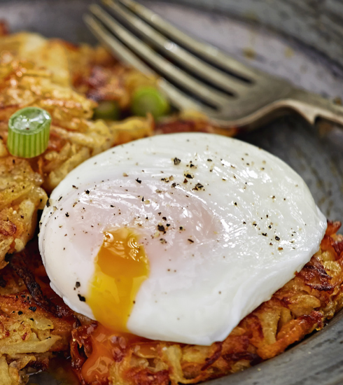 |  | Cooking Steps  Coarsely grate the celeriac and potato into a large, clean tea towel and, holding over the sink, squeeze out as much moisture as possible from the mixture. Tip into a bowl and stir through the flour and plenty of seasoning.  Heat a large frying pan and add enough oil to your taste. Form the mix into 8 patties, each about 10cm wide and 1cm thick. Fry in batches, if necessary, for 2-3 minutes or until golden underneath. Flip and fry for another 2-3 minutes until again golden underneath and cooked through. Keep warm in a low oven while you poach the eggs.  Fill a deep frying pan with gently simmering water. Crack the eggs into a small cup, one at a time, then drop gently into the water. Poach for 2-3 minutes or until the whites have just set. Scoop out with a slotted spoon and drain briefly on kitchen paper.  Whisk together the olive oil, mustard and white wine vinegar in a bowl with some seasoning, then tip into the salad leaves and toss well.  Divide the rösti between 4 plates, top each with a poached egg and freshly ground black pepper.  Also goes well with hollandaise sauce.

APPLE & RUM CAKE
Moderate | 60 minutes | Dessert | 4-6 Servings

Ingredients  4 cox apples  1 cup plain flour  1 teaspoons baking powder  ¼ teaspoon salt  8 tablespoons butter, softened  ¾ cup + 1½ tablespoons  granulated sugar  2 large eggs  1 teaspoon vanilla extract  ¼ cup dark rum  knob butter to grease the pan  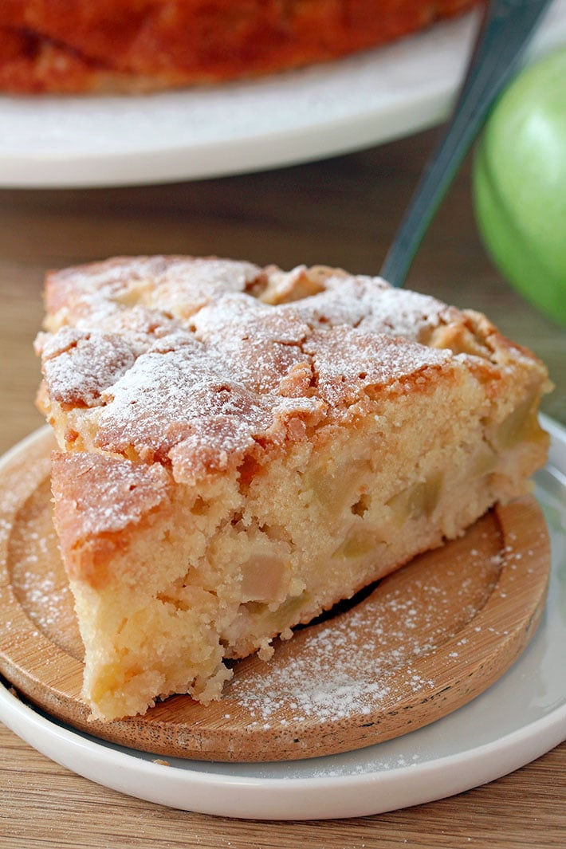 |  | Cooking Steps  Preheat the oven to 350 F and prepare a 9 inch spring form or cake pan by lining it with parchment paper and butter and then set it aside.  Peel the apples next and cut them into ½ inch dices, then set aside. In a medium dish, sift flour, baking powder and salt and set aside. In a large dish, beat butter and ¾ cup sugar, using medium-high speed, until it becomes light and fluffy, then add eggs and beat until well combined.  Next, beat in vanilla and rum, change the speed to low and beat in a ¼ of  flour mixture until just incorporated. Continue adding the same amount of the flour mixture until you use it all up, beating all the time. Fold in the apples and pour the batter in the pan that has already been prepared, spreading it evenly. Sprinkle 1½ tablespoon granulated sugar and bake for 40 minutes or until the top becomes golden brown or the toothpick comes out clean or with a few crumbs on it.  When the cake is done, take it out of the oven and leave in the pan for a few minutes to cool, then transfer, carefully on the cake plate and sprinkle with powdered sugar. Serve with vanilla or cinnamon ice cream, or with whipped cream.

CARAMELISED BAKED PEARS
Moderate | 80 minutes | Dessert | 4 Servings

Ingredients  4 medium to large pears  ¼ cup light brown sugar  ¼ teaspoon cinnamon (optional)  ¼ teaspoon nutmeg(optional)  ½ whole lemon, juice only  2 to 4 tablespoons butter,  cut into 1/4" cubes  ¼ teaspoon sea salt  ½ teaspoon vanilla extract   |  | Cooking Steps  Preheat oven to 400F. Line a 10"x7" or a 9"x9" baking dish with parchment paper if you prefer easier cleanup, or spray it with nonstick spray. If doubling the recipe use a 9"x13" baking dish or any other rimmed baking dish that will fit pears snugly to each other (see Note 1 at the bottom).  If using a firm pear, peel them. Remove the core with a melon baller or a small spoon. Leave the stems on for better visual appeal. If you're using softer pears keep the skin on to help them keep the shape as they bake.  Set the pears cut side up inside the pan. Drizzle with lemon juice to prevent browning. Sprinkle with brown sugar mixed with nutmeg and cinnamon (if using) and salt. Arrange the cubed pieces of butter on top of the pears. Drizzle with vanilla extract.  Bake for 30 minutes cut side up. Turn the pears cut side down. Spoon the caramel over the tops to prevent browning. Bake for another 20-50 minutes or until the pears are soft, and the caramel is thickened. The pears will shrink considerably if baked until the caramel is very thick.  Serve warm with vanilla ice cream, yogurt, sour cream, or a sprinkle of roasted walnuts or sliced almonds. Spoon the caramel over the pears.



