
THINK VEG BOX • THINK AUSTEN’S PREMIUM
D3 SPECTRUM BUSINESS CENTRE
ANTHONY’S WAY
ROCHESTER ME2 4NP
T: 01634 816100
E: contact@austensgroup.com
W: www.austensgroup.com

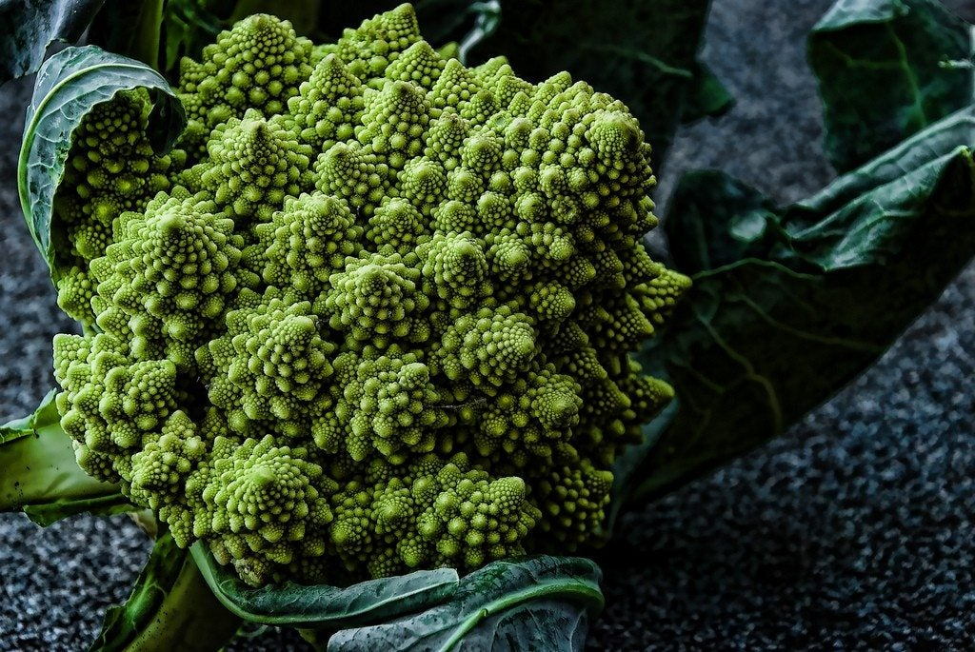
VEG BOX CONTENTS & RECIPES FOR WEEK COMMENCING 24TH NOVEMBER 2025

E A T L O C A L ⋅ L I V E B E T T E R

VEG BOX CONTENTS

BOX SIZE &  CONTENTS | SMALL  BOX | MEDIUM  BOX | LARGE  BOX | WHERE IT IS GROWN | STORAGE INSTRUCTIONS
LOCAL BRAEBURN APPLES | √ | √ | √ | HAWKHURST | ROOM TEMPERATURE
SATSUMAS | √ | √ | √ | SPAIN | ROOM TEMPERATURE
BANANAS | √ | √ | √ | COSTA RICA | ROOM TEMPERATURE
LOCAL KING EDWARD POTATOES | √ | √ | √ | BIRCHINGTON | COOL, DRY PLACE
LOCAL SAVOY CABBAGE | √ | √ | √ | THANET | REFRIGERATE
ENGLISH BROCCOLI | √ | √ | √ | LINCS | REFRIGERATE
COURGETTES | √ | √ | √ | SPAIN | REFRIGERATE
LOCAL ROMANESCU | √ | √ | √ | BROADSTAIRS | REFRIGERATE
ENGLISH LEEKS | X | √ | √ | LANCS | REFRIGERATE
LOCAL BUNCHED BEETROOT | X | √ | √ | BOUGHTON MONCHELSEA | REFRIGERATE
ENGLISH LOOSE CARROTS | X | X | √ | LINCS | REFRIGERATE
LOCAL VINE TOMATOES | X | X | √ | THANET | REFRIGERATE

SAVOY CABBAGE & SAGE LASAGNE
Moderate | 60 minutes | Main | 06 Servings

Ingredients  750ml whole milk  1 bay leaf  1 small onion  3 garlic cloves, bruised  6 lasagne sheets  ½ savoy cabbage, cored and cut into 2 cm strips  45g unsalted butter, plus extra for greasing  3 tbsp plain flour  6 fresh or dried chopped sage leaves  1 pinch freshly grated nutmeg  125g torn mozzarella  20g grated parmesan  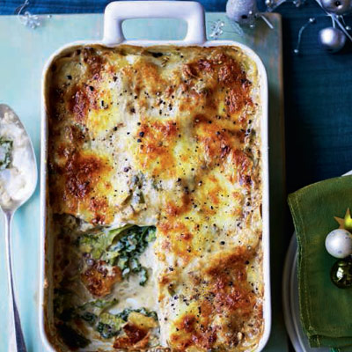 |  | Cooking Steps  Bring the milk to the boil with the bay leaf, onion and garlic. Set aside for 15 minutes to infuse, then strain.  Meanwhile, cook the lasagne sheets in boiling water for 3 minutes until al dente, then refresh in cold water. Drain and pat dry on a clean tea towel. Blanch the cabbage in boiling water for 3 minutes; drain. Pat dry thoroughly.  For the sauce, melt the butter over a low heat and add the flour and sage. Stir for 2 minutes, then slowly pour in the infused milk, whisking all the time until smooth. Simmer for 3-4 minutes. Add the nutmeg and season.  Preheat the oven to 200°C, gas mark 6. Grease a 22cm x 16cm baking dish. Set aside one third of the sauce and stir the cabbage into the rest. Cover the base of the dish with a little of the plain sauce, then top with 2 lasagne sheets. Cover with half the cabbage, then add another 2 lasagne sheets and the remaining cabbage. Top with the final 2 lasagne sheets, spoon over the remaining plain sauce and scatter with the cheeses. Bake for 40-45 minutes until golden.

BROCCOLI & CHEDDAR ORZO
Moderate | 45 minutes | Main | 04-06 Servings

Ingredients  225g cheddar cheese, shredded  400g broccoli  1 large onion  6 large cloves garlic  2 tablespoons olive oil  1¾ teaspoons ground sea salt, divided  ½ teaspoon freshly ground black pepper, divided  1 ½ teaspoons dry ground mustard  ¼ teaspoon ground cayenne pepper (optional)  450g dried orzo pasta  1 litre vegetable stock  235ml milk, any  2 tablespoons butter |  | Cooking Steps  Trim the stem end from the broccoli crowns. Cut the florets from the stems. Separate or cut the florets into 1 to 1 ½ inch pieces. Chop the stems into ¼ to ½ inch pieces and place in a separate medium bowl. Finely chop the onion then add to the bowl with the broccoli stems. Finely grate 6 large garlic cloves (about 4 teaspoons).  Heat 2 tablespoons olive oil in a large oven safe pan over a medium heat until shimmering, about 30 seconds. Add the onion and broccoli stems, 1 teaspoon of the salt and ¼ teaspoon of the black pepper. Cook, stirring occasionally, until the onion is translucent and the stems are almost tender, 5 to 7 minutes.  Add the broccoli florets, remaining ¾ teaspoon salt, remaining ¼ teaspoon black pepper, 1½ teaspoons ground mustard, and ¼ teaspoon ground cayenne if desired and stir to combine. Cook, stirring often, until the florets are vibrant green, 3 to 5 minutes.  Add the garlic and cook, stirring constantly, until fragrant, about 30 seconds. Add the orzo pasta and cook, stirring constantly, until lightly toasted, about 1 minute. Add the broth and stir to combine, scraping up the browned bits from the bottom of the pan. Increase the heat to high and bring to a boil.  Reduce the heat to maintain a very gentle simmer. Continue to cook, stirring every minute or so and scraping the bottom of the pot, until the orzo is a minute shy of al dente and most of the liquid is absorbed (but still glossy), 6 to 8 minutes or according to package instructions. Add the milk, stir to combine and simmer until the orzo is al dente but still saucy, about 1 minute more.  Remove the pan from the heat. Add 2 tablespoons butter and the cheese. Stir until the butter and cheese are melted and the orzo is glossy and saucy. Let sit for 5 minutes for the sauce to thicken before serving.
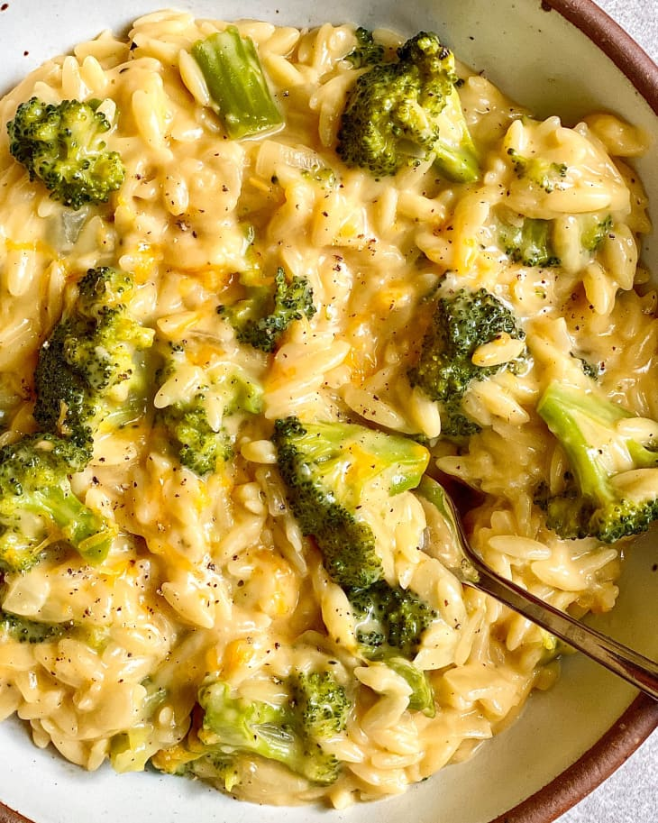

COURGETTE & PEA RISOTTO
Moderate | 40 minutes | Main | 04 Servings

Ingredients  1 tsp olive oil  2 small onions, halved and sliced  2 garlic clove, crushed  400g courgette, diced  risotto rice to feed 4  600 ml vegetable stock,  simmering in a saucepan  1 tbsp dried thyme  50g frozen peas, defrosted  50g parmesan  large knob butter  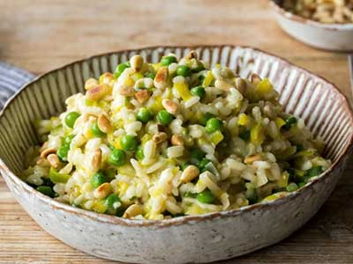 |  | Cooking Steps  Heat the olive oil in a pan and add the onion and garlic and stir over a medium heat for 4-5 minutes until softened.  Add the courgette to the pan and stir for a further 4 minutes.  Tip in the rice and stir to coat in the oil.  Add a ladle full of the hot stock to the pan and stir. When the stock has been absorbed, repeat with another ladle of stock and continue doing this until the rice is cooked and the stock has been absorbed,  Stir in the peas and cook for a further 5 minutes to heat through.  Add a large knob of butter and the parmesan, stir through and allow to sit for 2-3 minutes with a lid on the pan.  Stir through again and divide between 4 bowls.

SAUSAGE & LEEK BAKE

Easy | 45 minutes | Main | 04 Servings

Ingredients  700g potatoes, peeled and sliced  25g butter  450g herby sausages,  cut into thick slices  1 onion, peeled and sliced  4 leeks, cleaned and sliced  40g plain flour  450ml milk  110g smoked Cheddar  25g breadcrumbs  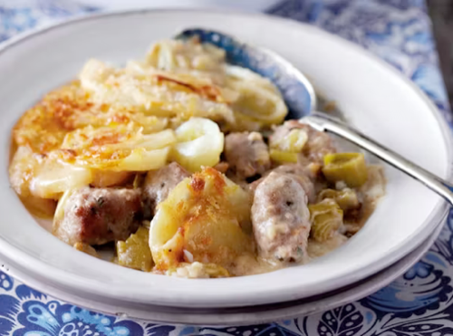 |  | Cooking Steps  Preheat the oven to 200°C/180°fan/Gas 6.  Cook the potatoes in boiling salted water for 4-5 minutes until just tender. Then drain.  Meanwhile, melt the butter in a large pan, add the sausage slices and cook for 5 minutes. Add the onion and leeks and cook for a further 5 minutes. Add the flour, cook for 1 minute, then gradually add the milk and 75g of the cheese, stirring. Bring to the boil and simmer for 1–2 minutes, stirring continuously.  Transfer to a 2-litre ovenproof dish, arrange the potato slices on top, sprinkle with the breadcrumbs and the remaining cheese and bake for 20 minutes until browned. Serve hot with roasted vegetables.

APPLE PIE BREAD
Moderate | 55 minutes | Dessert | 1 Loaf

Ingredients  ½ cup butter, room temperature  ½ cup maple syrup  ½ cup homemade apple sauce  1 tsp vanilla extract/essence  2 cups plain flour  2 tsp baking powder  1 tsp baking soda  1 tsp salt  2 tsp mixed spice  1/4 cup milk  2 braeburn apples, chopped  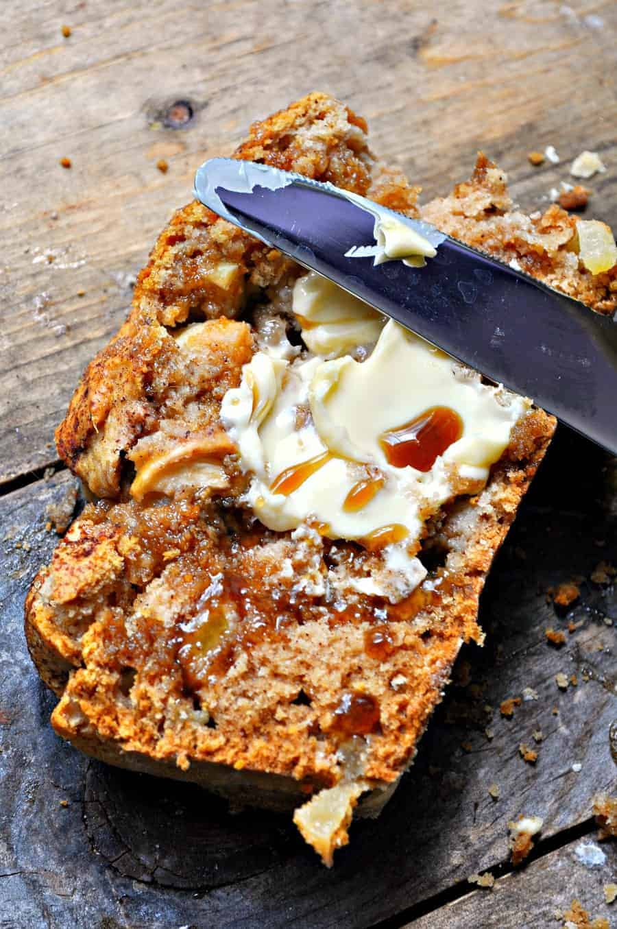 |  | Cooking Steps  Preheat oven to 350 degrees.  In a large mixing bowl, using a hand mixer or stand mixer, combine the butter and maple syrup. Now add the apple sauce and vanilla. Stir together until combined.  Now sift in the flour, baking powder, baking soda, salt and apple pie spice.  Begin stirring and adding the milk at the same time. Stir scraping down the sides as needed until fully combined. Now fold in the chopped apples.  Next, grease a bread pan. Pour the batter into the pan and bake at 350 degrees for 35-45 minutes or until a toothpick comes out clean.  Let cool before slicing. Serve plain, with butter and maple syrup or whatever your heart desires.

PAN FRIED BANANAS WITH CINNAMON & HONEY
Moderate | 15 minutes | Dessert | 04 Servings

Ingredients  2 bananas, cut  into ½" pieces  ½ tsp cinnamon  1 tbsp butter  2 tbsp honey  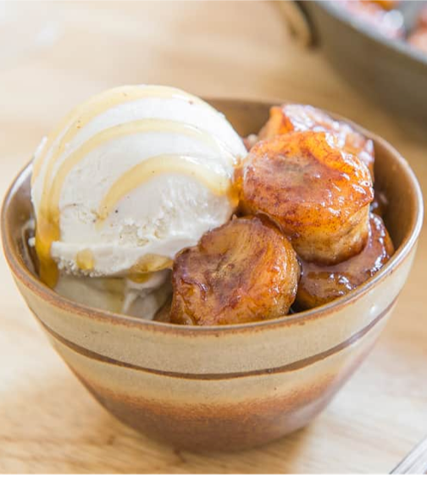 |  | Cooking Steps  Combine the cinnamon, butter and honey in a frying pan over medium-high heat until melted and combined.  Add the banana slices and cook for 4 minutes until the bottoms start to caramelize and turn golden brown. Adjust the temperature and cooking time as needed so that they don't burn.  Flip all the banana pieces and cook for another 4 minutes until the other side is golden brown.  Serve immediately over ice cream or yogurt.



